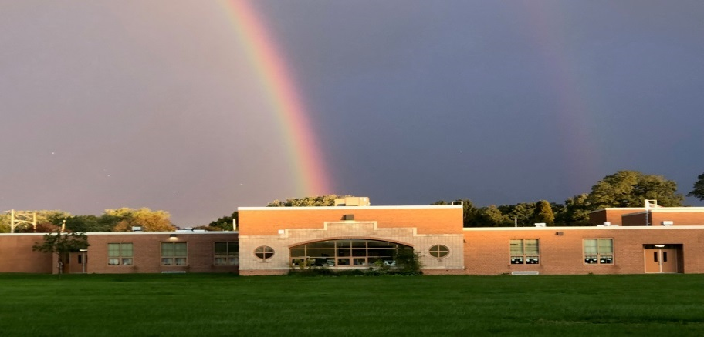
PLAN heer dugsi hoose
"In la hubiyo in uu jiro nidaam dugsiga in si buuxda ay hubisaa in maamulaha waxaa sahlay in ay u adeegaan sida hoggaamiye xoog tacliimeed oo shuraako la ah bulshada dugsiga, waxay keenaysaa koritaanka guusha iyo sii hagaajinta ee dugsiga."
Xeeladaha Dugsiga gaarka ah
2023-2024
- qorshaynta horumarinta dugsiga hoose-dhexe
  - falanqaynta Data
  - horumarinta Xirfadaha
  - Hirgelinta xeeladaha
  - Korjoogteynta iyo hagaajinta
- School Wide Taageerada Anshaxa Wanaagsan (SWPBIS)
  - Isticmaalka xogta
  - sharciyada iyo waxa laga filayo Common
  - Baridda iyo xoojinta Dhaqanada laga filayo
  - 4/1 wanaagsan in ay diidmo
Talaabooyinka Hirgelinta Dugsiga gaarka ah
- Ururi iyo dib u eegaan xogta
  - Achievement - PSSA, PVAAS, DIBELS, CDT
  - Dabeecadda - Xafiiska Anshaxa gudbinta, hakinta
  - Garasho - sahan Ardayga, macallinka, iyo waalidka
- horumarinta Xirfadaha
  - Power of Words Our - waxbarasho buugga
  - tababarka Respectful Ways
  - tababarka SWPBIS
- Waxbarashada Leadership Team / Professional Learning Communities
  - go'aan qaadashada la wadaago
  - masuuliyad la wadaago
  - xisaabtan la wadaago

